**Project Title:**

**Product Marketing and Selling Portal**

(By SEMESTER-IX of V Year M.Sc. (2019-20))

**Student Name:**Misha Thakkar

**Roll No:**5079

**Name of Company**: Gateway Group Of Companies

**Date of Submission**: 29-February-2020

**Synopsis Submitted To**

**K. S. School of Business Management**

M.Sc. – Computer Application and Information Technology



**Data Dictionary**

**“**A **Data Dictionary** is a catalogue of elements in the system.**”** These elements centre on the data and they structured to meet user requirements and organization needs, the major elements are data flows, data stores and processes. The Data dictionary stores the details and description of these elements.

**Why Data Dictionary is important?**

* To manage the details in large systems.
* To communicate a common meaning for all system elements.
* To documents the failure of the system.
* To facilitate analysis of the details in order to evaluate characteristics and determine where the system changes should be made.
* To locate errors and omission in system.

**What does Data Dictionary record?**

The Data Dictionary contains two types of description for all data following through system

* **Data Elements**
* Data Description
* Aliases
* Length
* Data values
* **Data Structure**
* Sequence Relationship
* Selection Relationship

**Table Name: tbl_Role**

**Description:** Used to store all type of role Information.

|  |  |  |  |  |
| --- | --- | --- | --- | --- |
| **Sr.no** | **Column Name** | **Data Type** | **Constraints** | **Description** |
| 1 | RoleId | Integer | Primary Key | It’s represent the id of role . |
| 2 | RoleName | Varchar(50) | Not Null | It’s represent the name of role. |

**Table Name: tbl_User**

**Description:** Used to store all users login and type Information.

|  |  |  |  |  |
| --- | --- | --- | --- | --- |
| **Sr.no** | **Column name** | **Data types** | **Constraints** | **Description** |
| 1 | UserId | Int | Primary key | It’s represent the user id. |
| 2 | RoleId | Int | Foreign Key | It’s represent the RoleId of user. |
| 2 | FirstName | Varchar(50) | Not Null | It’s represent the FirstName. |
|  | LastName | Varchar(50) | Not Null | It’s represent the LastName Of the user |
| 3 | Email | nvarchar(50) | Not Null | It’s represent the email. |
| 4 | Address | nvarchar(MAX) | Not Null | It’s represent the current address. |
| 5 | Password | nvarchar(50) | Not Null | It’s represent the password. |
| 6 | ContactNo | int | Not Null | It’s represent the contact No. of user. |
| 7 | IsActive | Bit | Not Null | It’s represent the User is active or not. |

**Table Name : tbl_Product_master**

**Description:** Used to store all Information about products.

|  |  |  |  |  |
| --- | --- | --- | --- | --- |
| **Sr.no** | **Column name** | **Data type** | **Constraints** | **Description** |
| 1 | ProductId | Int | Primary key | It’s represent the id of product. |
| 2 | QuantityId | Int | Foreign key | It’s represent the id of Quantity. |
| 3 | ProductName | Varchar(50) | Not null | It’s represent the name of product. |
| 4 | Price | Float | Not null | It’s represent the price of product. |
| 5 | Description | Varchar(100) | Not null | It’s represent the detail of product. |
| 6 | Image | nvarchar(50) | Not Null | It’s represent Image of the product. |
| 7 | EnterBy | Int | Null | It’s represent the id of the user. |
| 8 | EnterDate | DateTime | Null | It’s represent the date and time of entered data. |
| 9 | UpdateBy | Int | Null | It’s represent the id of the user. |
| 10 | UpdateDate | DateTime | Null | It’s represent the date and time of entered data. |

**Table Name : tbl_Location_master**

**Description:** Used to store all Information about Location.

|  |  |  |  |  |
| --- | --- | --- | --- | --- |
| **Sr.no** | **Column name** | **Data type** | **Constraints** | **Description** |
| 1 | LocationId | Int | Primary key | It’s represent the id of location. |
| 2 | CountryId | Int | Foreign Key | It’s represent the foreign key countryid . |
| 3 | StateId | Int | Foreign Key | It’s represent the foreign key stateid of location. |
| 4 | CityId | Int | Foreign Key | It’s represent the foreign key cityid name |
| 5 | Address | Varchar(200) | Not null | It’s represent the address. |
| 6 | LandMark | Varchar(100) | Not Null | It’s represent the landmark of the location. |
| 7 | Pincode | Bigint | Not Null | It’s represent the pincode of the location |
| 8 | EnterBy | Int | Null | It’s represent the id of the user. |
| 9 | EnterDate | DateTime | Null | It’s represent the date and time of entered data. |
| 10 | UpdateBy | Int | Null | It’s represent the id of the user. |
| 11 | UpdateDate | DateTime | Null | It’s represent the date and time of entered data. |

**Table Name : tbl_Event_master**

**Description:** Used to store all Information about Event.

|  |  |  |  |  |
| --- | --- | --- | --- | --- |
| **Sr.no** | **Column name** | **Data type** | **Constraints** | **Description** |
| 1 | EventId | Int | Primary key | It’s represent the id of Event. |
| 2 | EventName | Varchar(50) | Not Null | It’s represent the event name. |
| 3 | CountryId | Int | Not Null | It’s represent the foreign key country id. |
| 4 | StateId | Int | Not Null | It’s represent the Foreign key state id |
| 5 | City Id | int | Not null | It’s represent the Foreign key city id |
| 6 | StartDate | Datetime | Not null | It’s represent the starting date of Event |
| 7 | EndDate | DateTime | Not null | It’s represent the end date and time of event. |
| 8 | Description | Varchar(100) | Null | It’s represent the additional details about event |
| 9 | EnterBy | Int | Null | It’s represent the id of the user. |
| 10 | EnterDate | DateTime | Null | It’s represent the date and time of entered data. |
| 11 | UpdateBy | Int | Null | It’s represent the id of the user. |
| 12 | UpdateDate | DateTime | Null | It’s represent the date and time of entered data. |

**Table Name : tbl_Category_master**

**Description:** Used to store all Information about category.

|  |  |  |  |  |
| --- | --- | --- | --- | --- |
| **Sr.no** | **Column name** | **Data type** | **Constraints** | **Description** |
| 1 | CategoryId | Int | Primary key | It’s represent the id of Category. |
| 2 | CategoryName | Varchar(50) | Not Null | It’s represent the name of category. |
| 3 | EnterBy | Int | Null | It’s represent the id of the user. |
| 4 | EnterDate | DateTime | Null | It’s represent the date and time of entered data. |
| 5 | UpdateBy | Int | Null | It’s represent the id of the user. |
| 6 | UpdateDate | DateTime | Null | It’s represent the date and time of entered data. |

**Table Name : tbl_Order_Detail**

**Description:** Used to store all Information about Order of product.

|  |  |  |  |  |
| --- | --- | --- | --- | --- |
| **Sr.no** | **Column name** | **Data type** | **Constraints** | **Description** |
| 1 | OrderId | Int | Primary key | It’s represent the id of order. |
| 2 | ProductId | Int | Foreign Key | It’s represent the productId. |
| 3 | UserId | Int | Foreign Key | It’s represent the user Id. |
| 4 | Quantity | Int | Not null | It’s represent the quantity of the product |
| 5 | Amount | Float | Not null | It’s represent the amount . |
| 6 | OrderStatus | Bit | Not Null | It’s represent the status of order |
| 7 | OrderDate | dateTime | Not Null | It’s represent the date and time of order |
| 8 | EnterBy | Int | Null | It’s represent the id of the user. |
| 9 | EnterDate | DateTime | Null | It’s represent the date and time of entered data. |
| 10 | UpdateBy | Int | Null | It’s represent the id of the user. |
| 11 | UpdateDate | DateTime | Null | It’s represent the date and time of entered data. |

**Table Name : tbl_Quantity**

**Description:** Used to store all Information about Quantity.

|  |  |  |  |  |
| --- | --- | --- | --- | --- |
| **Sr.no** | **Column name** | **Data type** | **Constraints** | **Description** |
| 1 | QuantityId | Int | Primary key | It’s represent the id of Quantity. |
| 2 | QuantityAvl | Varchar(50) | Not Null | It’s represent the availability of the quantity. |
| 3 | EnterBy | Int | Null | It’s represent the id of the user. |
| 4 | EnterDate | DateTime | Null | It’s represent the date and time of entered data. |
| 5 | UpdateBy | Int | Null | It’s represent the id of the user. |
| 6 | UpdateDate | DateTime | Null | It’s represent the date and time of entered data. |

**Table Name: tbl_ProductCategory_Map**

**Description:** Used to store all product & category mapping Information.

|  |  |  |  |  |
| --- | --- | --- | --- | --- |
| **Sr.no** | **Column Name** | **Data Type** | **Constraints** | **Description** |
| 1 | ProductCategoryId | Int | Primary Key | It’s represent the id of this table. |
| 2 | ProductId | Int | Foreign Key | It’s represent the id of product. |
| 3 | CategoryId | Int | ForeignKey | It’s represent the foreign key of category. |

**Table Name: tbl_ProductLocation_Map**

**Description:** Used to store all product & location mapping Information.

|  |  |  |  |  |
| --- | --- | --- | --- | --- |
| **Sr.no** | **Column Name** | **Data Type** | **Constraints** | **Description** |
| 1 | ProductLocationId | Int | Primary Key | It’s represent the id of this table. |
| 2 | ProductId | Int | Foreign Key | It’s represent the id of product. |
| 3 | LocationId | Int | ForeignKey | It’s represent the foreign key of location. |

**UseCase Diagram**

**User:**

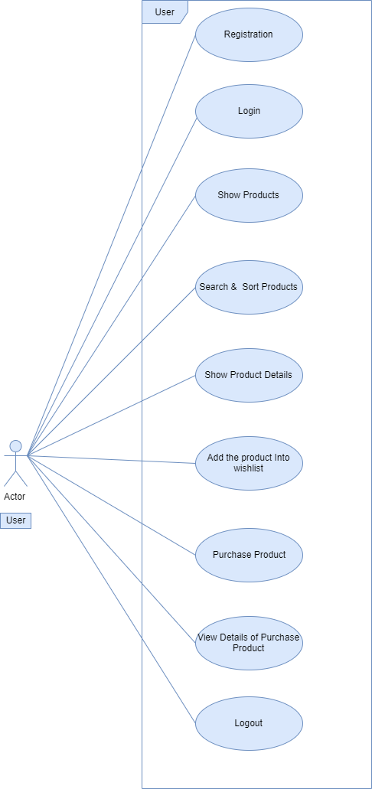

**2.Visitor**

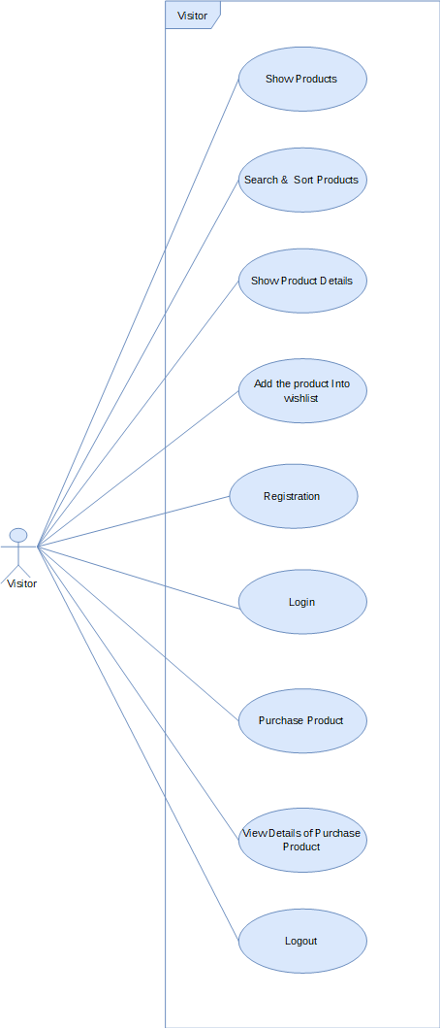

**3.Admin**

